ALISTAIR SPEED MEMORIAL 50
(INCORPORATING SVTTA HARRY ROBERTS)
SUNDAY 29 MAY 2022
8.00 AM START
COURSE WE.50/01

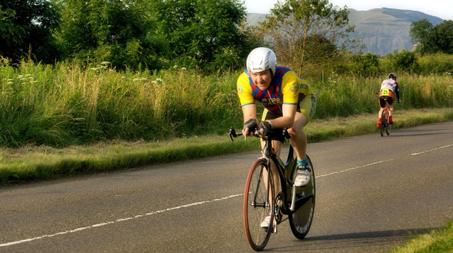

PROMOTED BY FIFE CYCLING ASSOCIATION
ON BEHALF OF CYCLING TIME TRIALS ASSOCIATION
UNDER THEIR RULES & REGULATIONS

Organiser: Mhairi Laffoley, 22 Frankfield Place, Dalgety Bay
Tel: 01383 822349 or email: mhairilaffoley@gmail.com

Alistair was introduced to the sport of cycling from a very young age by his dad, Archie, and he became a member of the Fife Century Road Club at the age of 8. He was to become a very active member and started competing at the age of 12 and continued to compete until his untimely death in September 2013 at the age of 49. He also regularly officiated at events and his time-keeping skills were second to none.

Over the years he travelled the length and breadth of the country, representing the Fife Century, taking part in events ranging from 10 miles to 12 hours, often having come straight from a night shift but he always had a smile and a friendly word for his fellow competitors and for those officiating.

Alistair was always at his happiest when cycling was involved and he was so proud that his nephew, Gavin, had taken up the family sport. They spent many hours together either at events or just going for a run on their bikes right up until the evening prior to his death.

It is hard to believe that it is nearly 9 years since we lost him, but the happy memories live on. I am sure that many of you will also have happy memories of time spent with Ali.

Event Headquarters (open from 7 am)
Freuchie Cricket Club, Muir Road, Freuchie KY15 7HW
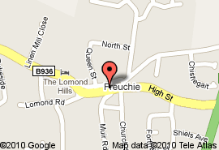
Parking
HQ
Weather permitting parking will be on the perimeter of the cricket club field at HQ, however, if we have had heavy rain prior to the event, we are unable to park on their grounds. If this is the case parking will be available on-street or at car park in the centre of Freuchie, just off Lomond Road. Please do not block driveways, lowered kerbs, etc.
PLEASE NOTE THERE WILL BE NO PARKING AT THE EVENT START

Parking
A92

PLEASE NOTE THAT IT IS NOW A DIFFERENT COURSE FROM PREVIOUSLY (although used in 2021)
Parking

Warming Up

Start
The start is approx. 3 ½ miles from Cricket Club on unclassified road (near the village of Dunshalt) Proceed from the hall and at mini roundabout take first junction and then immediate left. Continue on unclassified road to start point. Start on opposite side of road from 300 yds to go marker. Approx ¼ mile east of Dunshalt.
No room for parking or warming up at start line.

Course
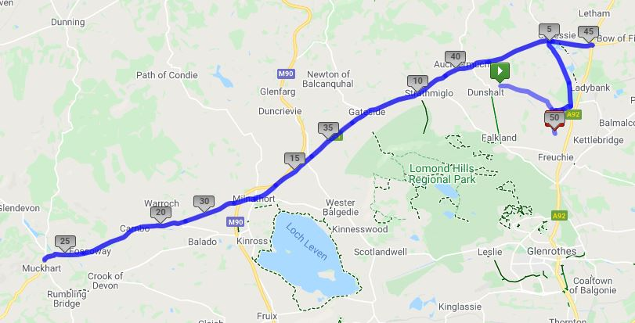
From start proceed along unclassified road to Shiels Triangle, turn left to Heatherhall Woods. Turn left onto (B937) to Trafalgar. Left on A91 and proceed to Milnathort. Straight over at mini roundabout remaining on A91 out to Yetts O Muckhart. Take right hand lane and follow one way section to return the way you came along A91 to Milnathort. Continue on A91 through Gateside and Auchtermuchty to Melville Lodges roundabout. Circumvent roundabout and retrace along A91 for approx. 1 mile. Turn left onto B937 to Heatherhall Woods. Turn right (DO NOT CUT THIS CORNER) Left at Shiels Triangle and proceed to finish at the Alex Mackie Bench on unclassified road approx. 1 mile north of Freuchie village.

ATTENTION
The roundabout in Milnathort does not have good site lines especially on the return leg. Riders will have to slow down adequately as they will not see if the road is clear to continue until the last minute. Riders not slowing appropriately for the junction and felt to be riding dangerously will be disqualified.

The course will be well signposted and marshalled.

ATTENTION

- New CTT Guidelines – All riders must have a working FRONT & REAR LIGHT fitted to their bikes. ALL riders must wear a helmet. NON-COMPLIANCE WILL MEAN NO START.
- Covid is still doing the rounds so If you are not well or are showing any signs of covid please do not come to the event.
- We will have access to the Cricket Club grounds for parking (please park on the perimeter & not on the pitch)
- When parking please use common sense and do not block any gates.
- Please remember to sign out after finishing and return your number (there will be a box for these so that volunteer is not having to handle them).
- We will have access to changing rooms so please use these for changing. You are asked not to change in full view of any residents. We are incredibly lucky to have this facility, so please do not give them any reason to take it away.
- Please bring your own pins if you need them.

RESULTS
- Due to Covid Restrictions being lifted we will be able to read out the results and have prize giving at HQ after the last rider has finished. There will be teas/coffee and light refreshments back at HQ – there will be a donations box for these for charity.

SUMMARY
- Please use common sense at all times due to the current situation that we are all living in. We want to make sure that everybody is safe plus we DO NOT want to give the general public any excuse to complain and have events stopped.

Thanks
Many thanks to all the volunteers helping today without them the race would not be able to go ahead. Thank you also to those of you who have generously donated towards the prize fund today, including the SVTTA.

Prizes

Mens Lady’s Vet’s Lady Vet
^{1st} ^{1st} ^{V40} ^{FV40}
^{2nd} ^{2nd} ^{V50} ^{FV50}
^{3rd} ^{3rd} ^{V60} ^{FV60}
^{4th} ^{4th} ^{V70}
^{V80}

SVVTA Member on Standard SVTTA Team on Standard
1st
2nd

Alistair Speed Spot Prize

One rider one prize apart from SVTTA prizes.

THERE WILL BE NO NUMBER 1 AS THIS HAS BEEN LEFT BLANK IN HONOUR OF ALISTAIR

FCA Open 50
No | NAME | CLUB | CAT | START | FINISH
1 |  |  |  | 8.01
2 | Dave Kirton | Kennoway RC | V | 8.02
3 | Penny Rother | Edinburgh RC | FV | 8.03
4 | Fred Denton | St Christophers CC | V | 8.04
5 | Gavin Laffoley | Fife Century RC | Sen | 8.05
6 | Lorraine Masterton | Edinburgh RC | FV | 8.06
7 | Stewart Mitchell | Deeside Thistle | V | 8.07
8 | Sarah Emslie | Edinburgh RC | FV | 8.08
9 | Robert McGraw | Deeside Thistle | V | 8.09
10 | Sarah Scott | Edinburgh RC | F | 8.10
11 | Stephen D’Arcy | Musselburgh RCC | V | 8.11
12 | Gerard McGuire | Pentland Velo | V | 8.12
13 | Willie McColl | Musselburgh RCC | V | 8.13
14 | Michael Perkins | Eat Plants Not Pigs | V | 8.14
15 | Robert Marshall | Team Andrew Allan Architecture | V | 8.15
16 | Carol Middleton | Ythan CC | FV | 8.16
17 |  |  |  | 8.17
18 | Chris Hunter | Glasgow Ivy CC | V | 8.18
19 | Joanne Clark | Royal Albert CC | FV | 8.19
20 | Jonny May | Dundee Thistle | V | 8.20
21 | Neil Glover | Musselburgh RCC | V | 8.21
22 | Kirsten Cameron | Team Andrew Allan Architecture | FV | 8.22
23 | Scott Hutchinson | Dunfermline CC | V | 8.23
24 | Robert Brown | EH Star Cycling | V | 8.24
25 | Derek Ditty | Velocity 44 RT | V | 8.25
26 | Alan Manson | SVTTA | V | 8.26
27 | Liam Scott Douglas | Dooleys RT | Sen | 8.27
28 | Alexandra Ligeti | Vanelli-Project GO | F | 8.28
29 | David Henderson | EH Star Cycling | V | 8.29
30 | Jon Fairclough | Kelso Wheelers | V | 8.30
31 | Robin Downie | Team Andrew Allan Architecture | Sen | 8.31
32 | Mike Giles | Ythan CC | V | 8.32
33 |  |  |  | 8.33
34 | Bill Groves | EH Star Cycling | V | 8.34
35 | Darren Kean | Fullarton Wheelers | Sen | 8.35
36 | Christina Murray | Army Cycling | FV | 8.36
37 | Vincent Pickering | St Christophers CC | V | 8.37
38 | Graham Jones | Edinburgh RC | V | 8.38
39 | Marc Preece | Dunfermline CC | V | 8.39
40 | Alistair Merry | Dundee Thistle | Sen | 8.40
41 | David Reeves | Dundee Thistle | V | 8.41
42 | Richard Sanderson | Kinross CC | Sen | 8.42
43 | Stuart MacCallum | Team Andrew Allan Architecture | V | 8.43
44 |  |  |  | 8.44
45 | Jesse Dawson | Vanelli-Project GO | V | 8.45
46 | Andrew Gallacher | SVTTA | V | 8.46
47 | Sean Quinn | Law Wheelers | V | 8.47
48 | Angus Wilson | Team Andrew Allan Architecture | V | 8.48
49 | Stewart Burke | GTR-Return to Life p/bStreamline | Sen | 8.49
50 | David MacNeil | Team Andrew Allan Architecture | Sen | 8.50
51 | John Waller | EH Star Cycling | Sen | 8.51
52 | Craig Duncan | Team Andrew Allan Architecture | Sen | 8.52
53 | Randle Shenton | Legato Racing Team | V | 8.53
54 | Douglas Watson | GTR-Return to Life p/b Streamline | V | 8.54
55 | Robbie Mitchell | Auchencrow Thistle CC | V | 8.55

